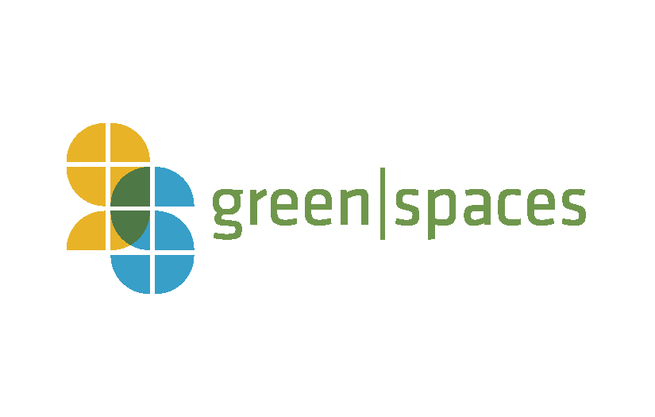
Green Drinks Sponsorship

Since 2008, Green Drinks has been a casual meeting of green-aware individuals for the betterment of Chattanooga and abroad. Green Drinks is an international program that holds monthly meetings in cities all over the world, meetings at which people from all areas of business, academia, government, and non-government mingle.

Sponsoring Green Drinks provides local businesses with an opportunity to highlight their company to other local businesses, contractors, developers, architects and the general public. Green Drinks take place on the last Wednesday of the Month.

Green Drinks Monthly Sponsorship: Cost of Appetizers & Beverages
- Provide appetizers & beverages for average 50 people
- Logo with link on event promotions via facebook, twitter, website and e-newsletter – over 4000 subscribers
- Able to provide brochures or other material handouts at Green Drinks
- 5 minutes to speak about your company at Green Drinks

Green Drinks Annual Sponsorship: $2500
- Logo with link on all green drink event promotions via facebook, twitter, website and e-newsletter – over 4000 subscribers
- Able to provide brochures or other material handouts at all Green Drinks
- 5 minutes to speak about your company at all Green Drinks

If you do not have a venue with the ability to host 60 people, we recommend finding a co-host with a space large enough or the green|spaces office is available for use.

For questions or to apply to be a sponsor, please contact: Madison Rollings at madison@greenspaceschattanooga.org or 423-648-0963

